|  |  |
| --- | --- |
| **Exercise No**:12  **Date**:03.04.25 | **Lucas Kanade and KLT Tracking** |

## AIM:

To apply Lucas Kanade algorithm on two frames and for video using KLT Tracking for tracking the

features.

**CODE:**

# Lucas Kanade and KLT Tracking

**import** cv2

**import** numpy **as** np

**import** gdown

**def** read_video(url):

file_id = url.split("/d/")[1].split("/")[0]

download_url = f'https://drive.google.com/uc?id={file_id}' gdown.download(download_url,"video.mp4", quiet=False) **return** cv2.VideoCapture("video.mp4")

**def** play_video(cap):

**while** cap.isOpened():

ret, frame = cap.read()

**if not** ret:

### break

cv2.imshow("Video Playback", frame)

*# Press 'q' to quit early*

**if** cv2.waitKey(25) & 0xFF == ord('q'):

### break

cv2.destroyAllWindows() cap =

read_video("https://drive.google.com/file/d/16czHsa364vmD5lnAHgJRXSTAUFDWLrWH/view?us p=sharing")

Downloading...

From: https://drive.google.com/uc?id=16czHsa364vmD5lnAHgJRXSTAUFDWLrWH To: C:\Users\sanka\PYTHON\COMPUTER VISION\video.mp4

100%|█████████████████████████████████████████████████████████████████████████████|

8.13M/8.13M [00:07<00:00, 1.13MB/s]

play_video(cap)

# Lucas Kanade for Two Frames

**def** lucas_kanade_two_frames(cap): cap.set(cv2.CAP_PROP_POS_FRAMES,0) ret, old_frame = cap.read()

**if not** ret:

print("Failed to read the first frame")

### return

old_gray = cv2.cvtColor(old_frame, cv2.COLOR_BGR2GRAY)

features = cv2.goodFeaturesToTrack(old_gray, maxCorners=100, qualityLevel=0.3, minDistance=7, blockSize=7)

lk_params = dict(winSize=(15, 15), maxLevel=2,

criteria=(cv2.TERM_CRITERIA_EPS | cv2.TERM_CRITERIA_COUNT, 10,

0.03))

mask = np.zeros_like(old_frame) ret, new_frame = cap.read()

**if not** ret:

print("Failed to read the second frame")

### return

new_gray = cv2.cvtColor(new_frame, cv2.COLOR_BGR2GRAY)

next_points, status, _ = cv2.calcOpticalFlowPyrLK(old_gray, new_gray, features, None, **lk_params)

good_new = next_points[status == 1] good_old = features[status == 1]

**for** i, (new, old) **in** enumerate(zip(good_new, good_old)): x_new, y_new = new.ravel()

x_old, y_old = old.ravel()

mask = cv2.line(mask, (int(x_new), int(y_new)), (int(x_old), int(y_old)), (0, 255, 0), 2)

new_frame = cv2.circle(new_frame, (int(x_new), int(y_new)), 5, (0, 0, 255), -

1)

output = cv2.add(new_frame, mask)

cv2.imshow('Lucas-Kanade Optical Flow (First Two Frames)', output)

cv2.waitKey(0) cv2.destroyAllWindows()

lucas_kanade_two_frames(cap)

# OUTPUT:

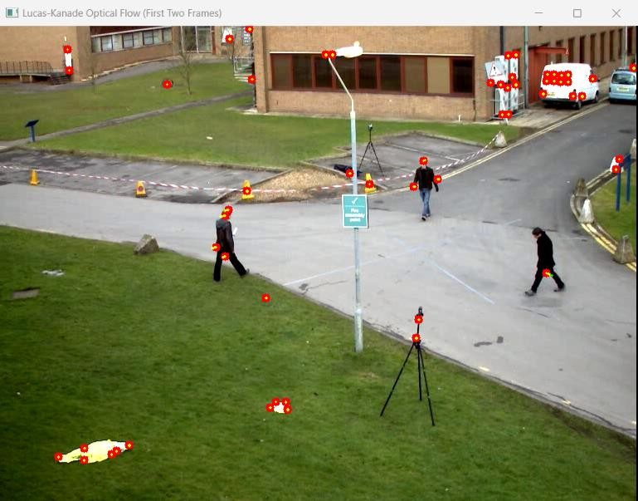

**Lucas Kanade and KLT for Video**

ret, old_frame = cap.read()

old_gray = cv2.cvtColor(old_frame, cv2.COLOR_BGR2GRAY)

features = cv2.goodFeaturesToTrack(old_gray, maxCorners=100, qualityLevel=0.3, minDistance=7, blockSize=7)

lk_params = dict(winSize=(15, 15), maxLevel=2,

criteria=(cv2.TERM_CRITERIA_EPS | cv2.TERM_CRITERIA_COUNT, 10,

0.03))

mask = np.zeros_like(old_frame) cap.set(cv2.CAP_PROP_POS_FRAMES,0)

**while** True:

ret, frame = cap.read()

**if not** ret:

print('Video Finishes')

### break

frame_gray = cv2.cvtColor(frame, cv2.COLOR_BGR2GRAY)

next_points, status, _ = cv2.calcOpticalFlowPyrLK(old_gray, frame_gray, features, None, **lk_params)

good_new = next_points[status == 1] good_old = features[status == 1]

**for** i, (new, old) **in** enumerate(zip(good_new, good_old)): x_new, y_new = new.ravel()

x_old, y_old = old.ravel()

mask = cv2.line(mask, (int(x_new), int(y_new)), (int(x_old), int(y_old)), (0, 255, 0), 2)

frame = cv2.circle(frame, (int(x_new), int(y_new)), 5, (0, 0, 255), -1)

output = cv2.add(frame, mask) cv2.imshow('KLT Tracking', output)

old_gray = frame_gray.copy()

features = good_new.reshape(-1, 1, 2)

**if** cv2.waitKey(30) & 0xFF == ord('q'):

### break

cv2.destroyAllWindows()

## RESULT:

Thus, Lucas Kanade algorithm on two frames and for video using KLT Tracking for tracking the features was written and executed successfully.